Slumdog Millionaire


The film tells the story of two brothers growing up in a very large slum in the biggest city in India, Mumbai.
The film starts quite close to the end of the story, where we see Jamal, the younger of the two brothers, in a Mumbai police station. He is eighteen years old. The police have arrested him because he is taking part in the popular TV quiz show ‘Who Wants to Be a Millionaire?’, and some people think he is cheating.
He has already given the right answers to lots of questions and now has the chance to win a huge amount of money. He doesn’t have much of an education, so how could he know all the answers?
The film then goes back in time and shows that Jamal knows the answers because of things that happened to him, his brother Salim and a girl called Latika in the past.
Task 1. Answer these questions:
- What kind of film is that?
- Who are the main heroes of the film?
- How old is Jamal?
- Where does he live?
- What game show did he take part in?
- Why did the policeman arrest him?
- Is Jamal a well-educated person? Why/Why not, give your own ideas.
- How could he know all the answers and get to the final of the show?
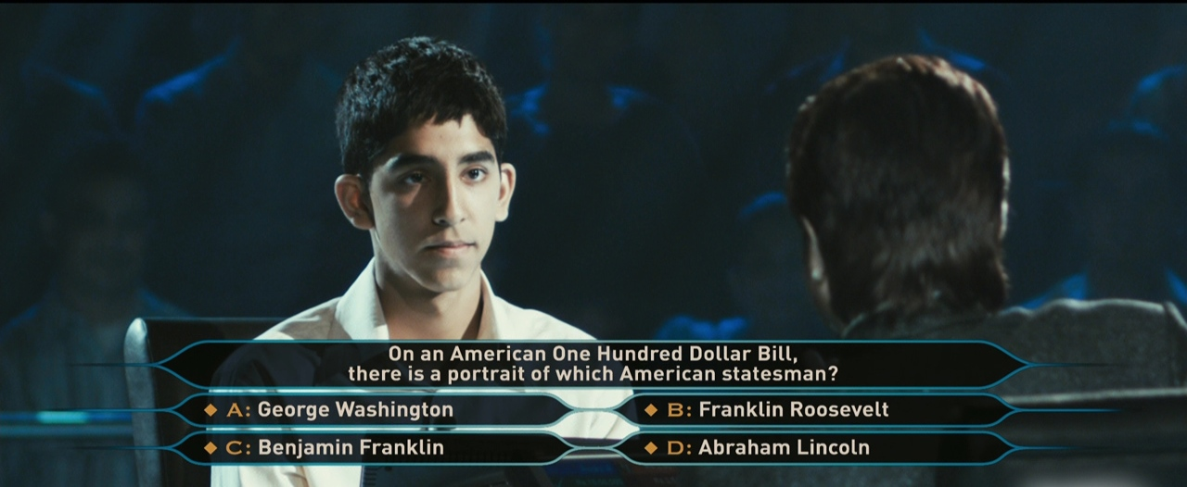
Task 2. Match the words with the definitions:
- cheat | - the power which controls what will happen in the future; fate
- applause | - an office where people answer customers' questions by using the telephone
- call center | - to make someone talk more than usual, especially about things they shouldn’t talk about
- confess | - ​secretly ​provided with an ​electronic ​device that ​records ​conversations
- tough guy | - to behave in a dishonest way in order to win or to get an advantage, especially in a competition, game, or examination:
- loosen sb’s tongue | - criticize you ​severely
- to be wired up | - a child who doesn’t have parents
- accomplice | - to admit, especially to the police, that you have done something wrong or illegal
- give a hell | - a poor locality in extremely dirty conditions
- unconscious | - a person who helps someone such as a criminal to do something wrong
- slum | - the sound of many people clapping their hands together and shouting
- flashback | - physically or emotionally strong person
- interrogate | - ask questions aggressively or formally
- destiny | - A person who fainted
- orphan | - a strong memory of a past event that comes suddenly into a person's mind

Task 3. Watch episode 1 and answer these questions:
- Jamal is in the interrogation room. What is the policeman doing to loosen his tongue?
- What do you think “It is written” can suggest?

- What does Jamal do for a living?
- Jamal is called a chai-wallah (tea maker) by the host and the audience laughs. Why does the host encourage such a reaction from the audience?
- What qualities does Jamal have, do you think? How can you describe him?


Task 4. Watch episode 2 and say if the statements are true or false:

  - The boys are playing football on the football filed.
  - Jamal and Salim are afraid of being caught and taken to the police station.
  - The boys are trying to hide in the school.
  - They call the policemen “cats”.
  - The mother stops the policeman from punishing her children.
  - They are taken to school in the end.
  - A teacher is reading “Three Musketeers”.


Watch the last segment and discuss:

- What did a small boy do to get the autograph?
- How did he know the answer to the first question?
- What was shocking?
- How is life in India different from life in your country? Think and give 5 reasons.
- Would you like to take part in such a show?

GET READY
Make the plot line of what you have learnt about the story so far and scenes you have seen in these segments.
