Interesting facts about Australia
Short history
First people came to Australia from Indonesia and they travelled on boats. It was about 40,000 years ago and they are called the Aborigines.
In 1770 British Captain James Cook came to New South Wales and Australia became a British colony. The British started to send English criminals there and they made it a British prison colony.
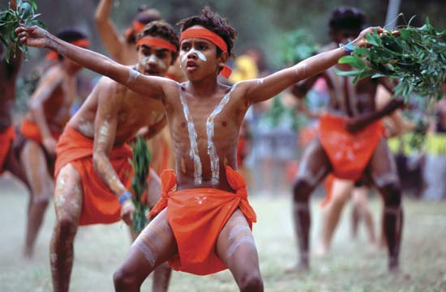
In 1901 Australia became a free nation but remained (zůstala) a part of British Commonwealth.

Uluru

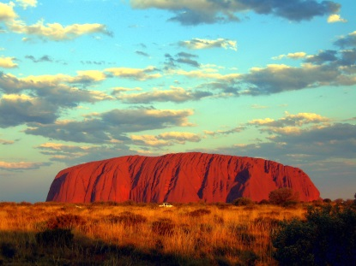
is Australia´s most famous rock and it is also called Eyers Rock. It is about 600 million years old and it was once at the bottom of the sea. It is one of the largest monoliths in the world and it is made of sandstone (pískovec). You can climb to the top of the rock and have a wonderful view of the outback (Australské vnitrozemí). On top of the rock there are valleys, caves (jeskyně) and strange shapes. It was a sacred (svaté) place for the Aboriginal people.

The climate
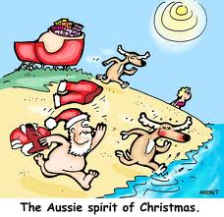
Australia lies in the Southern. Hemisphere. It means that if you go to the south, it gets colder. In the north of the country it is always hot. In Australia there are hot summers and mild (mírný) winters. There is snow only in the Australian Alps and in Tasmania. When people in Europe have winter, the Australians have summer. Therefore they celebrate Christmas in the middle of summer and on the beach).

Australian Aboriginal Flag
is one of the official flags. There are three colours. The black represents the Aboriginal people, the red – the earth and the yellow represents the sun.

Australian National Flag
It is a blue with the Union Jack (- the British flag). The Union Jack represents the link with Britain. The star has got seven points. 6 points represent the 6 States and one point represents the Territories. The small stars show the Southern Cross which can be seen in the sky in the southern hemisphere (polokoule)

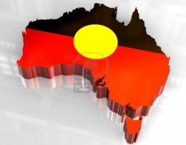
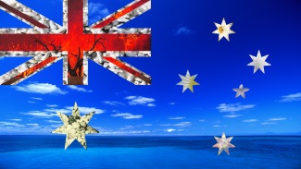
Great Barrier Reef
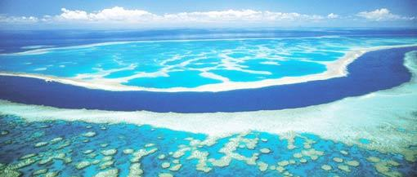
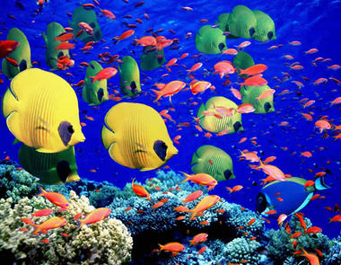
is the world's largest coral reef system (systém korálových útesů). You can see it from the space and it is over 2,000 km long and it has got more than 900 islands. There are many different types of corals, fish and other sea animals.
The Aborigines
are the native people in Australia. They came about 40,000 years ago from Indonesia. Many Australian words come from their language, for example: koala, kangaroo, boomerang, and didgeridoo.
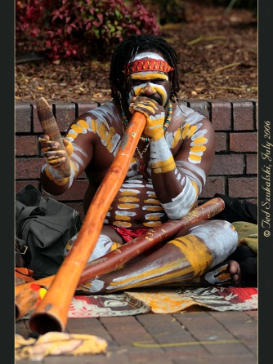
A didgeridoo is a long wooden wind (dechový) instrument and it looks like a long thin wooden trumpet.
Today there are about 670,000 Aborigines.

Answer the questions – your partners can help you.
1 Who were the first people who came to Australia? Where did they come from? How did they travel?
____________________________________________________________________________________________________________________________________________________________________________________________________________________________________________________________________________________________________________
2 Who was James Cook? When did he arrive in Australia?
_________________________________________________________________________________________________________________________________________________________________________________________________________________________________
3 What colours does the Aboriginal flag have? What do they represent?
_________________________________________________________________________________________________________________________________________________________________________________________________________________________________
4 What symbols appear on the Australian official flag?
______________________________________________________________________________________________________________________________________________________
5 What is Uluru? What is another name for it?
_________________________________________________________________________________________________________________________________________________________________________________________________________________________________
6 What is interesting about the Great Barrier Reef? How many islands are there?
_________________________________________________________________________________________________________________________________________________________________________________________________________________________________
7 What is the climate like in Australia? What do the Australians celebrate in summer?
_________________________________________________________________________________________________________________________________________________________________________________________________________________________________
8 What Australian words come from the Aboriginal language?
_________________________________________________________________________________________________________________________________________________________________________________________________________________________________
9 What is a “didgeridoo”?
____________________________________________________________________________________________________________________________________________________________________________________________________________________________________________________________________________________________________________

