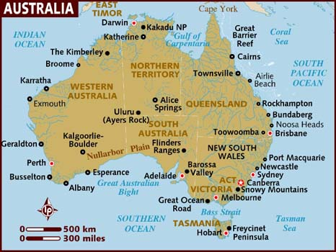
Australia
Australia is the 6th biggest country in the world. Only Russia, China, Canada, USA, and Brazil are bigger. It is the world’s largest island.

Even though the country is so big it only has about 23 million inhabitants. 88 % of all Australians live in the big cities or smaller towns which makes big areas of the country empty.

Australia lies in the southern hemisphere which means that the more south you go, the cooler it gets. In the north parts of the country it is always hot. The rest of the country has really hot summers and mild winters. Snow only falls in the Australian Alps and in Tasmania. When we have winter in Europe the Australians have summer. So they celebrate Christmas in the middle of the summer!

History
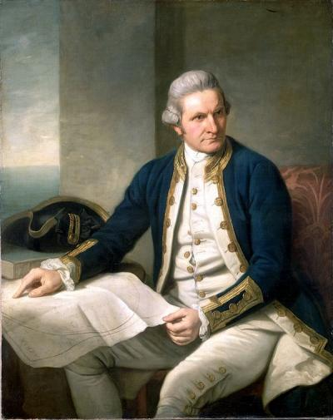
Australia was unknown to most people until 1770. That year the British explorer Captain James Cook arrived to the country on his ship The Endeavour. His mission was to sail to Tahiti and watch the planet Venus pass between the earth and the sun. Scientists needed the observations to figure out the distance between the earth and the sun. But Cook also had a secret mission. He was supposed to find the unknown southern continent. In April 1770 Cook reached the Australian coast and planted the British flag and claimed the land for Great Britain. The Captain called the land New South Wales.

For about 20 years nothing more happened with New South Wales. At the end of the 18th century and the beginning of the 19th century many people came to the country. Until the revolution in America in 1776 many British criminals were sent to the states. But after the revolution the English authorities needed some place new for these people. Someone remembered Cook’s voyage to Australia and thought that New South Wales would be a good place. It was certainly far away. Poor people and criminals were sent to Australia to keep them out of trouble and out of England. After seven years the prisoners were free to return to England but most of them couldn’t afford it.

The first group of people sent to the land were called “The First Fleet” and landed in January in 1788 and built the first European settlement in Australia – that was the starting of the city Sydney. The country was called New South Wales until the 1820s when it got its present name: Australia.
When James Cook reached the new continent he met the native people – the Aborigines. They had already been in the land for 40,000 years.

Nature and animals
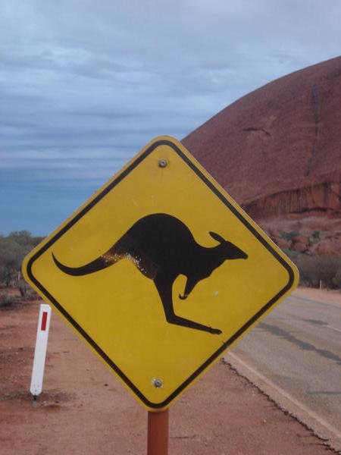
Australia is famous for its wildlife. The most famous animals are probably the koala and the kangaroo. The kangaroo, or roo for short, has become Australia’s national symbol. The word “kangaroo” was the first Aboriginal word in the English language. There are several spices of kangaroos. The red kangaroos are the biggest ones and they are found in the middle of the country. A male can be 2 metres and weigh 90 kilos. The grey kangaroos are slightly smaller and mainly found in the east and south. The wallabies and the wallaroos are smaller relatives of the kangaroos. The red kangaroos can hop as fast as 70 km/h.

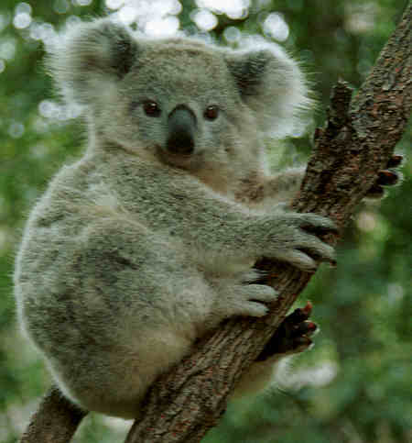
The koala bear looks like a living teddy bear with its soft, thick greyish-brown fur and round ears. Koalas can measure up to 75 centimetres and weigh 14 kilos. Basically, koalas spend their lives eating eucalyptus leaves and sleeping in trees. Koalas can sleep twenty hours a day. Koalas rarely drink any water. They get most of the water from all the leaves they nibble. In fact, the name koala comes from an Aborigine word meaning “no drink”.
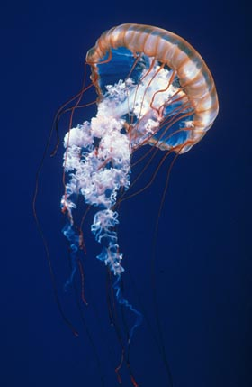
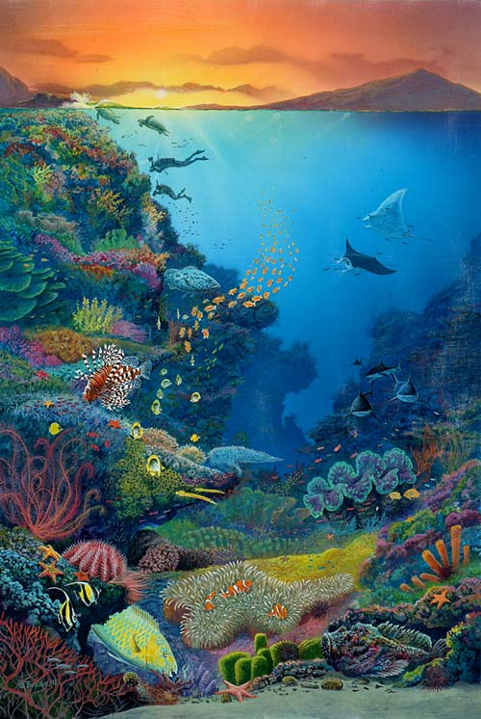
There are over 126,000,000 sheep in Australia, which use half the continent for grazing. They aren’t dangerous but you still need to be careful because there are some dangerous animals around. The most dangerous ants in the world are the Australian Bulldog Ants. They can be up to 4 centimetres long. You also have to watch out for extremely poisonous spiders, sharks, and snakes, not to mention the Sea Wasp, a jellyfish. This jellyfish is the world’s most deadly stingy animal and it can weigh up to 2 kilos. Most people wear swimsuits or some other protection to feel safe and protect their bodies. If you are stung you need to see a doctor – fortunately there is an anti-venom for the sting.

Australia has more beaches than any other country – there are about 7000 of them. The first life-saving club in the world was founded on Bondi Beach in Sydney on 1906. It has saved many surfers’ lives.

If you don’t like to lie in the sun or surf, there is always the Great Barrier Reef to visit. It is the world’s largest coral reef and it is located off the coast of Queensland. It stretches over 2000 kilometres and consists of 900 islands and 3000 coral reefs. A dangerous threat to the Great Barrier Reef - and to many other tropical reefs – is global warming. When temperature rises and the water remains too warm too long, the corals die.

The dingo fence
The dingo fence is the longest fence in the world. It is 5,531 kilometres long. It is called “the dingo fence” because it is supposed to keep out dingoes, Australia’s wild dogs, from the sheep farms. It was built in the 1880’s.

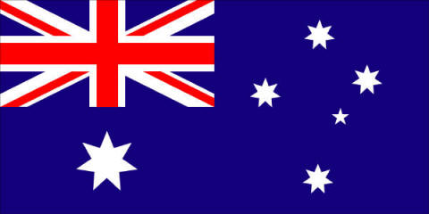
The flag
There are five stars on the right side of the Australian flag which represent the Southern Cross. These five stars helped ships to navigate in the Southern Hemisphere in olden times.

The flag is dark blue with the British Union Flag (Union Jack) in the upper left corner. The British flag symbolizes Australia’s historic links with the UK and the Queen. There is also a large 7-pointed star under the Union Flag. This star symbolizes Australia’s six states and the Northern Territory. Some people think that Australia should have a new flag without the British flag in the corner. The Australian flag is also very easily confused with New Zealand’s flag, which is very similar.
FACTS AND STATISTICS
Official name: Commonwealth of Australia
Head of State: Queen Elizabeth II
Capital: Canberra
Biggest city: Sydney
Population: about 23 million
Official language: English
Major ethnic groups: British & Irish 78%,
Other European 14%, Aborigine 1%, Asian 7%.

The Commonwealth of Australia is a monarchy. Queen Elizabeth II is Queen of Australia as well as of the UK and many other countries. Some of these countries are Canada, Jamaica, Barbados, and New Zealand. All of these independent countries were once British colonies.

Australia consisted earlier of six British colonies. In 1901 the colonies joined together to form a new country, the Commonwealth of Australia. The old colonies changed into new states. Besides the six states Australia has two territories: the Northern Territory and the Australian Capital Territory, Canberra. Each state has its own government and laws. There is also a federal government which makes laws for the whole country. The government is lead by the Prime Minister, who is the leader of the biggest party in the House of Representatives, one part of the Australian Parliament. Julia Gillard is Prime Minister at the present.

In 1902, Australia was one of the first countries to give women the right to vote. But it wasn’t until 1967 that the Aborigines, the first people in Australia, finally received the right to vote! If you are 18 years of age or older, you have to vote in the parliamentary and state elections. If you don’t you have to pay a fee.

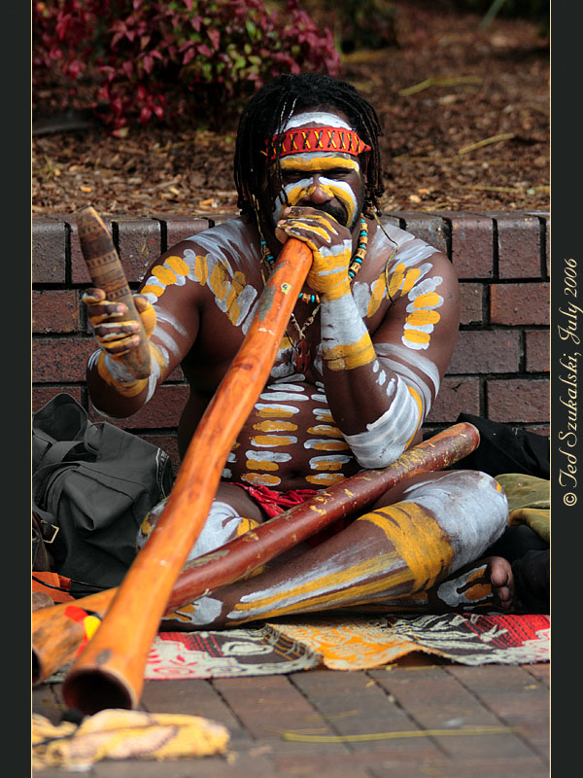
The Aborigines
The native population of Australia is called the Aborigines. They have lived in Australia for thousands of years. Many English words come from their language, for example: koala, kangaroo, boomerang, and didgeridoo. Everyone knows what a boomerang is but what is a didgeridoo? It is a musical instrument made out of a long wooden cylinder.

Most of the Aborigines died out after the Europeans arrived. No one knows how many the Aborigines were when the Europeans arrived. They may have been as many as 750,000. But the contact with the whites was a catastrophe. There were a lot of fights and many Aborigines were killed, or taken as slaves. Sadly enough, white settlers who killed Aborigines weren’t punished until as late as 1838. But all Aborigines weren’t killed directly by the whites. They died in the diseases the Europeans brought with them. Today there are about 275,000 Aborigines in Australia.

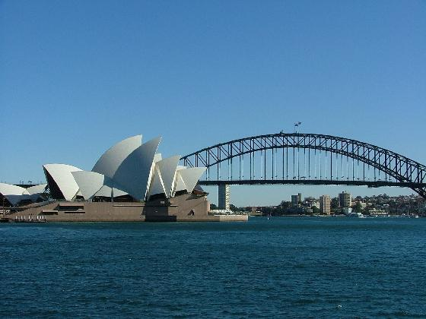
Cities
There are five cities with more than 1 million inhabitants in Australia; Sydney, Melbourne, Brisbane, Perth, and Adelaide. Sydney is the biggest (about 4, 6 million inhabitants) and the oldest city in Australia. Many of the street names are the same as in London; Oxford Street, Bayswater Road and King’s Cross Road. Like most big cities in Australia Sydney is very modern with many skyscrapers. Sydney’s two most famous buildings are the Sydney Opera House and the Sydney Harbour Bridge. They have become symbols of Australia. The Opera House was opened by Queen Elizabeth in 1973 and is designed by the Danish architect Jørn Utzon. The Harbour Bridge opened in 1932 and is 503 metres long. It has 8 carriageways, two railway tracks, a bike path, and a path for pedestrians.

Melbourne is the second biggest city in Australia with about 4 million inhabitants. Melbourne and Sydney have always been rivals. Between 1856 and 1911 Melbourne was bigger but then Sydney grew bigger. Melbourne still has a lot to offer though. It is a multi-cultural city with many immigrants from Greece, Vietnam, and China, so Melbourne is supposed to have the best restaurants in Australia.

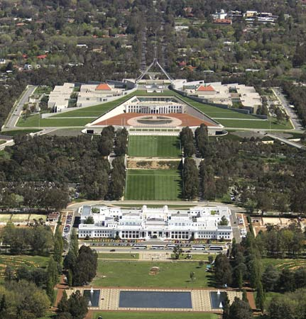
Canberra is the capital city, but it only has a population of about 350,000. It is a very “green” city with many parks and shady streets. It was built because Sydney and Melbourne couldn’t agree on anything, not even which of them that should be the capital city. The Parliament moved to the city in 1927. About half the people who work in Canberra have government jobs; there are no other industries.

The Parliament buildings in Canberra

- Translate the underlined words.
- Answer the questions.
- Do the crossword.
- Fill in the names on the map.

Questions
- What countries are bigger than Australia?
- Why are big areas in Australia empty?
- What happens with the temperature if you go further south in Australia?
- What is the weather like around Christmas in Australia?
- What was the name of James Cook’s ship?
- What was Cook’s secret mission?
- Why were poor people and criminals sent to Australia?
- When did Australia get its present name?
- Which animal is the country’s national symbol?
- What are the smaller relatives to the kangaroos called?
- How many hours per day can a koala sleep?
- What does the word “koala” mean?
- What are the most dangerous ants in the world called?
- Why do many people wear swimsuit in the ocean?
- Where was the first life-saving club started?
- What is the biggest threat to the Great Barrier Reef?
- What effect does global warming have on the coral reefs?
- The Dingo fence is the longest in the world. What is its purpose?
- What does the following symbolize in the Australian flag?
a) The five stars on the right side?
  - Union Jack?
  - The large 7-pointed star?
- Why is the British queen Head of State in Australia?
- What is the name of the Prime minister?
- You are Australian and over 18 years old. You don’t care to vote in the election. What happens?
- What are the native people of Australia called?
- Many words in English come from the Aborigines. Name at least 2.
- Today, there aren’t many Aborigines left. How come?
- Name three of the biggest cities in Australia.
- Name the two most famous buildings in Sydney.
- Why is Melbourne supposed to have the best restaurants in the world?
- What is special with the capital city, Canberra?

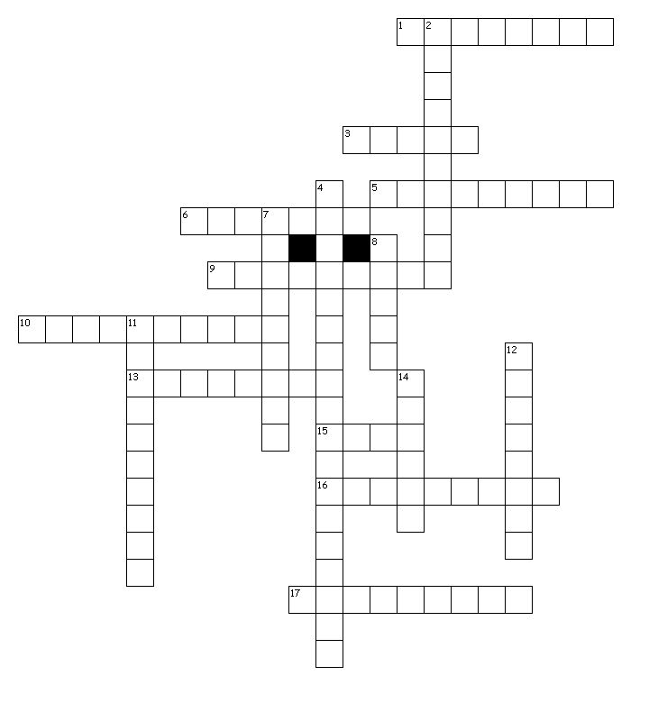

Across
1. Island south of Australia
3. The Prime Minister's first name.
5. The name of the queen.
6. The Architect of the Opera House in Sydney comes from this country.
9. Smaller relative to the kangaroo.
10. An Aboriginial wooden instrument.
13. The capital city.
15. The Prime Minister's last name.
16. The......,James Cook's ship.
17. The Sea Wasp is a ….

Down
2. The native people of Australia.
4. The world's biggest coral reef.
7. Australia's secong biggest city.
8. Australian wild dog.
11. The koala's main food.
12. Something you wear when you are swimming in the ocean.
14. Australia's biggest city.



 
 
 
 
 
 
 
 
 
 
 

 
 
 
 
 
 
 
 
 
 
 

