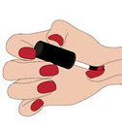
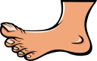
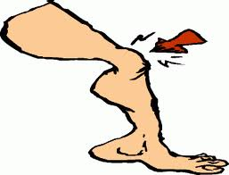
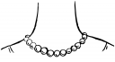
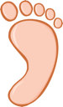
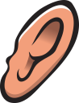
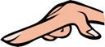
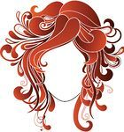
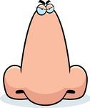
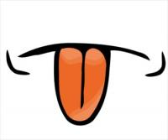
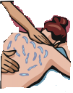
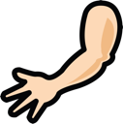
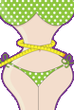
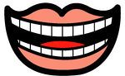
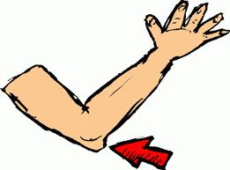
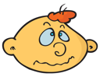
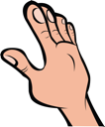
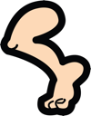
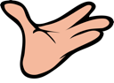
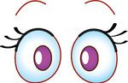
LET'S HAVE FUN WITH BODY PARTS!
Find ten body parts in the word search.

EYELASHESYLSINJELRENBGAHAIRBECOKLDOERCRSWAISTOKTEARMVUWRISTNOSE
Put the letters in the correct order.

1 siwta: _________________
2 ywroeeb: ________________
3 eusodrhl:_________________
4 mhuto:_________________
5 griefn:_________________
6 noetug:_________________
7 loewb:_________________
8 lapm:_________________
9 mhbtu:_________________
10 lani: _________________
Match the words and the pictures.
1 eyes 2 nose 3 back 4 hair 5 leg 6 foot 7 hand
8 arm 9 fingers 10 head 11 ear 12 neck 13 elbow 14 tongue 15 knee 16 palm 17 sole 18 teeth 19 nails 20 waist
How many …s have you got? Write the body parts in the correct column.

onetwomore than two

head / foot / arm / face / toe / back / mouth / tooth / eyelash / nose / hand / finger / eyebrow / nail / knee
Find the odd word out.
1 eye – hair – hand – ear
2 toes – eyes – fingers – nails
3 hand – ear – eye – head
4 palm – leg – knee – foot
5 mouth – tooth – tongue - nose
6 face – eyebrow – eyelashes – eye
7 elbow – sole – arm – hand
8 shoulder – hand – foot – back
9 waist – back – leg – stomach
10 toes – wrist – fingers - hands
What body parts are they?

1 The part at the end of your arm: __________________
2 The part in the middle of your arm where it bends: ____________
3 One of the two parts in your head that you see with: __________
4 The front part of your head: _______________
5 The bottom part of your foot: ______________
6 One of the five parts at the end of each hands: ______________
7 One of the long parts of the body that is used for walking or standing: _________________
8 One of the hard white things in your mouth that you use for eating: __________________
9 The front part of your body below your chest and above your legs: ____________________
10 One of the two parts of a person that are used for hearing: _______________
face tooth elbow finger stomach hand ear leg eye sole

