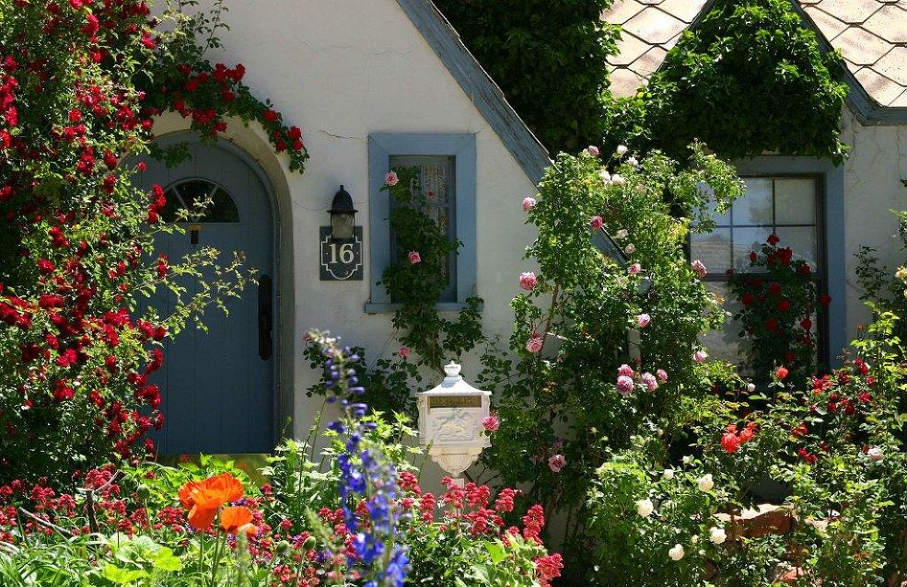
CITY OR COUNTRYSIDE?
My name is James. I live in the countryside, in a stone cottage which is over 100 years old. The cottage is near a small village. I love living here because it's green and calm. There aren't many cars or buses and the streets are clean. You can go for a walk late at night because there it’s a very safe place. You can even leave your doors open, nobody will come in or steal anything.
We know all the neighbours and at the end of the day, people get together at the main square and chat. We go to bed early, as there isn't much to do in the evening. There isn't any disco or cinema. We also don't have a youth club, but the children can play safely in the lanes or in the fields.
You can sleep very well at night because there is no noise. You can hear the birds singing or the rain pouring. The air is so pure and cool and you can see millions of bright stars in the night sky.
It is a bit difficult in winter. Sometimes it snows a lot and then we are isolated for a few days but I prefer living in the countryside and I will never leave this peaceful and beautiful place.

My name is Debbie. I live in a big city and I love it. Of course, there are lots of cars and buses, bikes and motorbikes, people trying to cross the streets. Traffic jams are normal and the air is bad. However, there are lots of advantages too. There are more workplaces in the city, better schools, nicer shops, finer restaurants and bars, hundreds of cinemas and theaters, art galleries and museums. If you want to go for a walk, you can go to one of the parks. Of course, children can't play in the streets, but there are lots of youth clubs and amusement parks where children can enjoy themselves. It’s always very busy, day and night, but I will never ever move from here.

TRUE - FALSE – INFO NOT GIVEN

1: James’s cottage is nearly 100 years old.
2: The city’s air will become cleaner in the future.
3: The children sometimes play in the city streets.
4: In the countryside, some people like to swim in the river.
5: James loves living in the countryside because it is very green.
6: People go to bed early in the countryside because they feel so tired.
7: In the city, there are more activities and places to visit.
8: Debbie lives in the city, but she doesn’t like it very much.
9: James has a nice car, a black horse, a wife and two children.
10: James will be moving to the countryside next year.
11: James enjoys going to the village cinema at the weekend.
12: It sometimes snows in the city.
13: It’s very quiet in the countryside and the air is clean.
14: Debbie has lived in the city for over twenty years.
15: The city has issues with traffic congestion and pollution.
16: Debbie doesn’t have any nice friends, so she is very lonely.
17: The winter snow can be a problem in the countryside.
18: Village life is probably healthier than the city.
19: In the countryside, people must lock the doors if they go out.
20: In the city, there are electrical power cuts nearly every week.

GENERAL QUESTIONS & DISCUSSION
1: What are the advantages and disadvantages of living in the city?
2: What are the advantages and disadvantages of living in the countryside?
3: Do you live in a city, town or in a village?
4: What do you like best about where you live?
5: In the place where you live, is there anything that could be improved?
6: Do the stars shine more brightly at night in the countryside? If so, why?

