**Aussie slang (strine)**

You are going to watch a video of Australian actress Margot Robbie. She is going to explain some typical Aussie slang.

The video goes pretty quickly, so you might need to stop and rewind a few times.

Complete the table below with the Aussie slang words from the video.

Good luck!

**CONTINUE ON NEXT PAGE**

[](https://www.youtube.com/embed/qNZIJmEZ91g?feature=oembed)

|  |  |
| --- | --- |
| **English word** | **Aussie slang** |
| lazy person |  |
| hard work |  |
| flip-flops |  |
| vomit |  |
| pants |  |
| pick-up truck |  |
| bathing suit |  |
| toilet |  |
| mosquito |  |
| young surfer |  |

**Can you figure out some more on your own?**

*Tip: An important feature of strine is that words are often shortened.*

See if you can match the words in the box with the list of words in the table.

|  |  |
| --- | --- |
| afternoon | mosquito |
| barbeque | an English person |
| candy | sunglasses |
| complain | sweater |
| dinner | swim suit |
| dodgy | thank you |
| expensive | TV |
| friend | trash |
| great | vegetables |
| hello | very full |

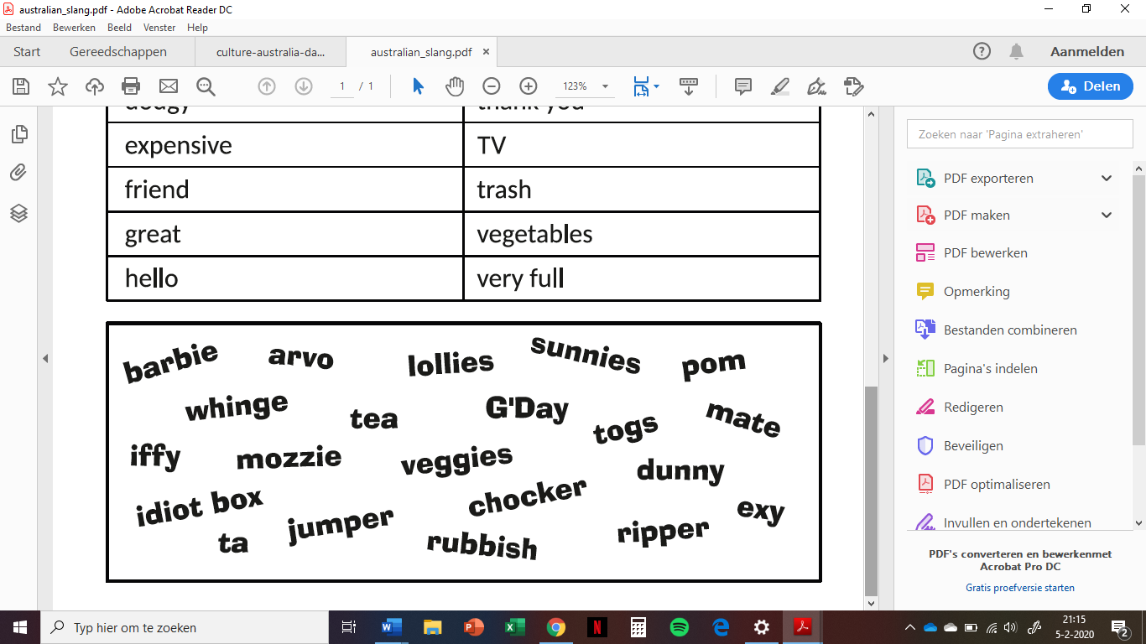

***Which word is left?***

**Finished before the end of class, continue with a small reading exercise on the next page.**

**Reading**

*Have a look at the words in the box. Then read the text and fill the gaps with these words.*

Australia -- continent -- opera -- smaller -- big -- island -- Sydney -- capital city

Australia is a ________ country. It is also a ______________ which consists of the mainland and the _____________ of Tasmania as well as _______________ islands. The ________________ of Australia is Canberra. The biggest part which you can see on your left is Western Australia. On your right you can see Queensland (on the top) and Victoria (at the bottom). Between them there is New South Wales. In the middle there is the Northern Territory (on the top) and South Australia.

The biggest Australian city is ______________. It has got a beautiful ______________ building which looks like a ship with huge white sails.

The most important Australian festival takes place on the 26th of January and it is called the _______________ Day.